

**NAME:** BYRON CONDOR

**SUBJECT**: OBJECT ORIENTED PROGRAMMING

**NRC:** 3638

**Workshop #4**

Configuration of environment variables:

* Configuration of javac:

1.-

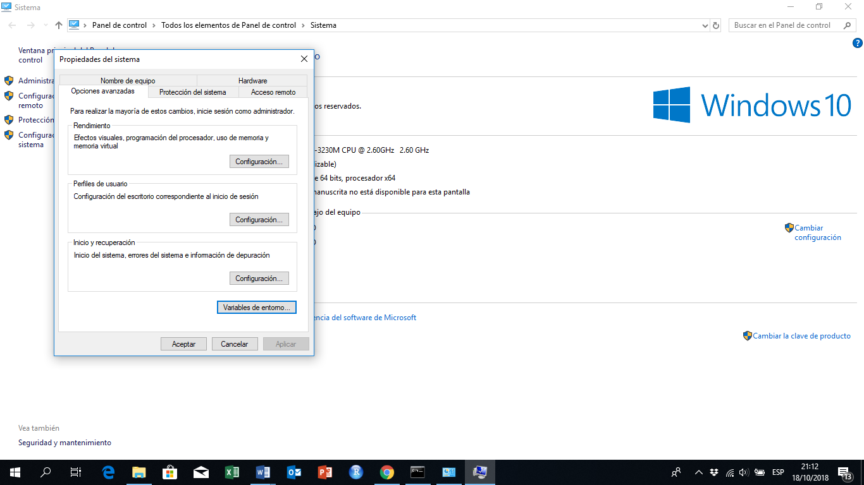

2.-

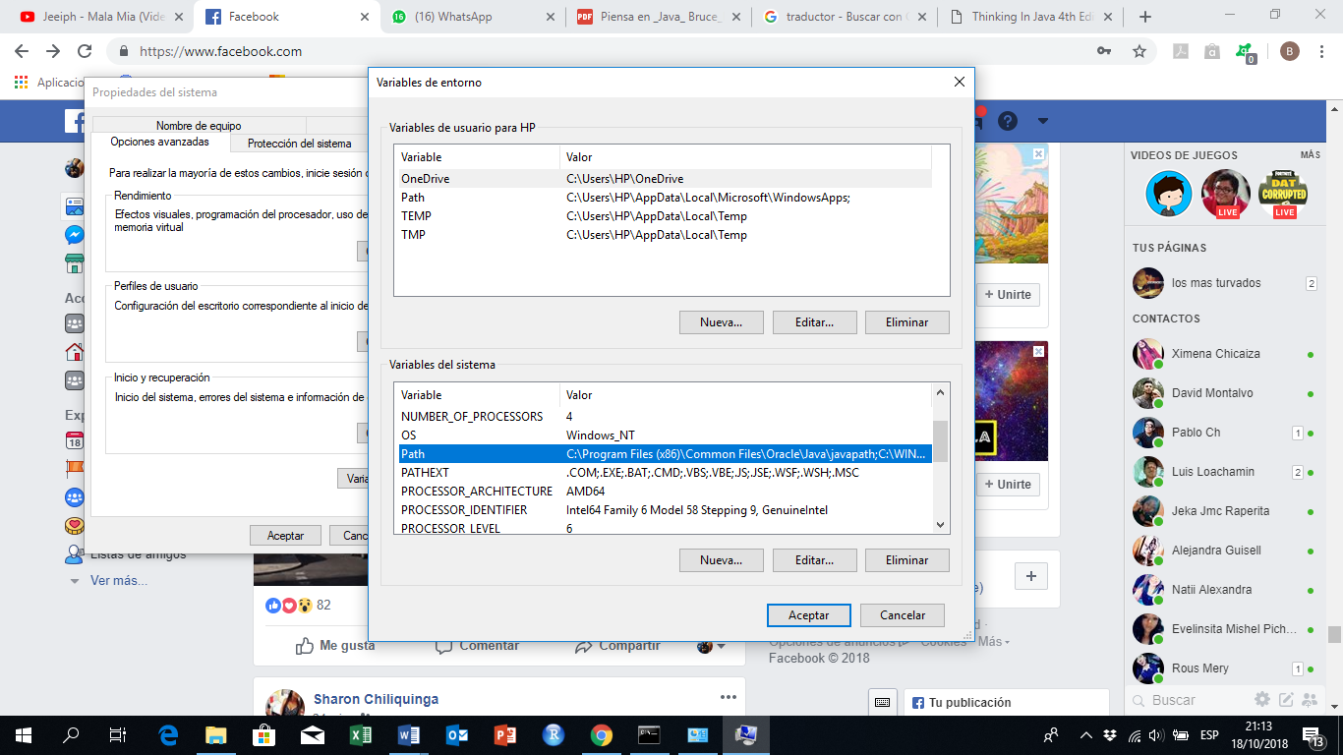

3.-

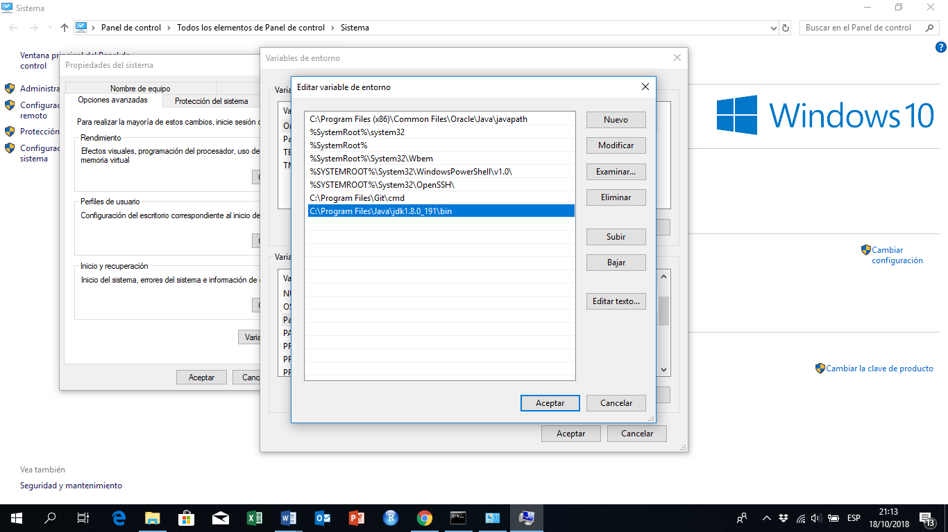

4.-

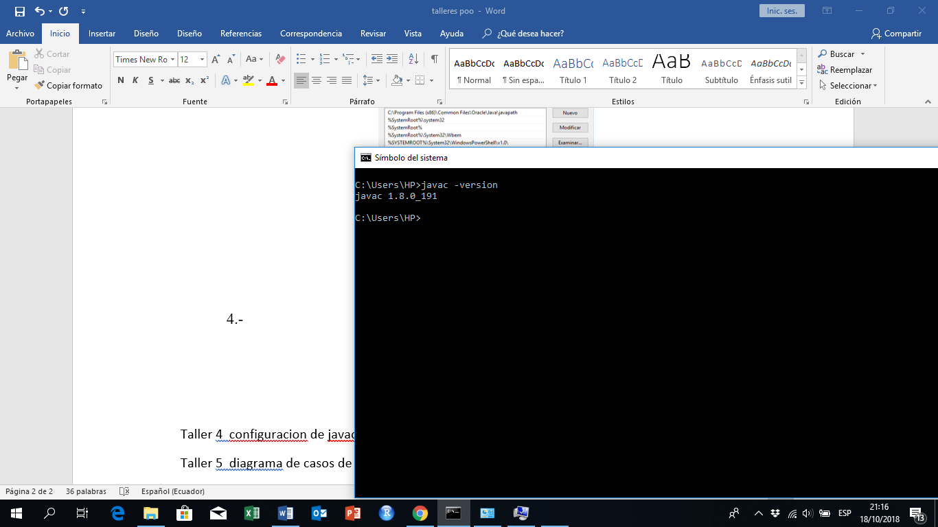

* Configuration of classpath:

1.-

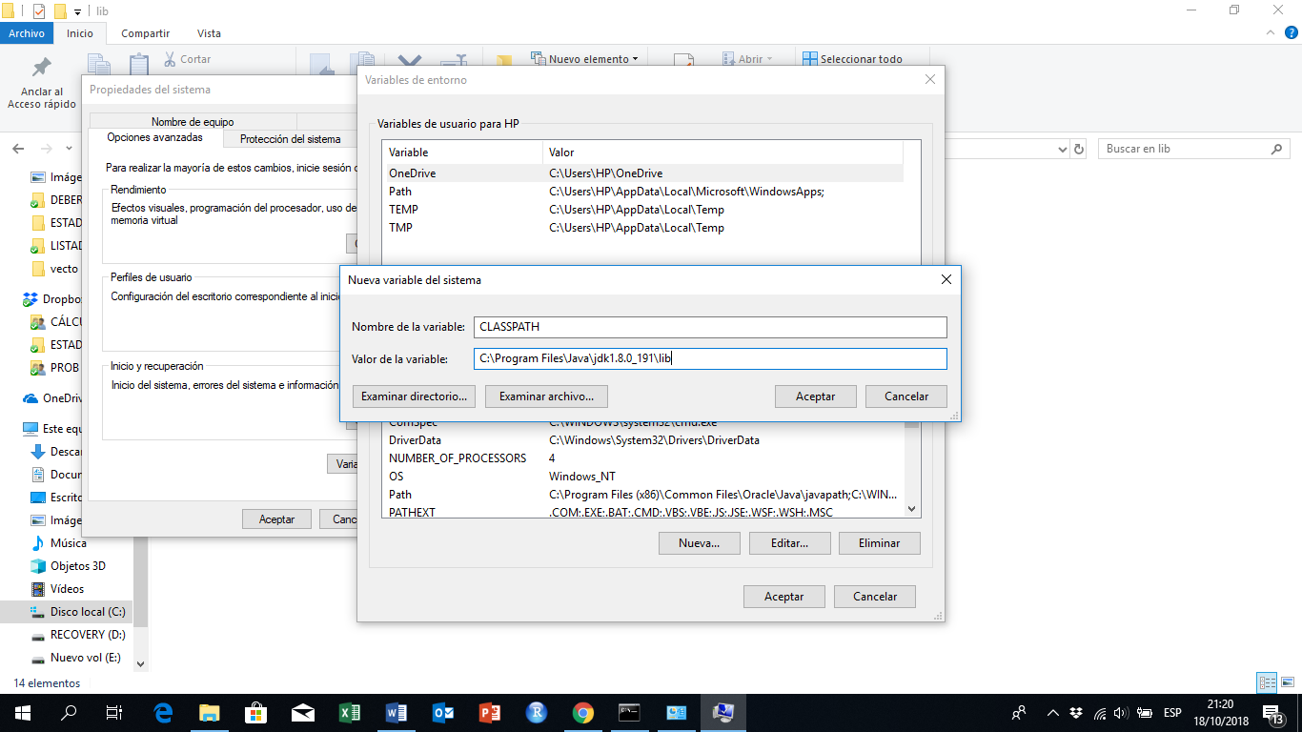

2.-

